**OurEnvironment.co.nz**

* Similar layout to LINZ website, but more on how the land has been used
* Slopes around the Turitea area, colour legends, visually appealing, and very easy to follow  
  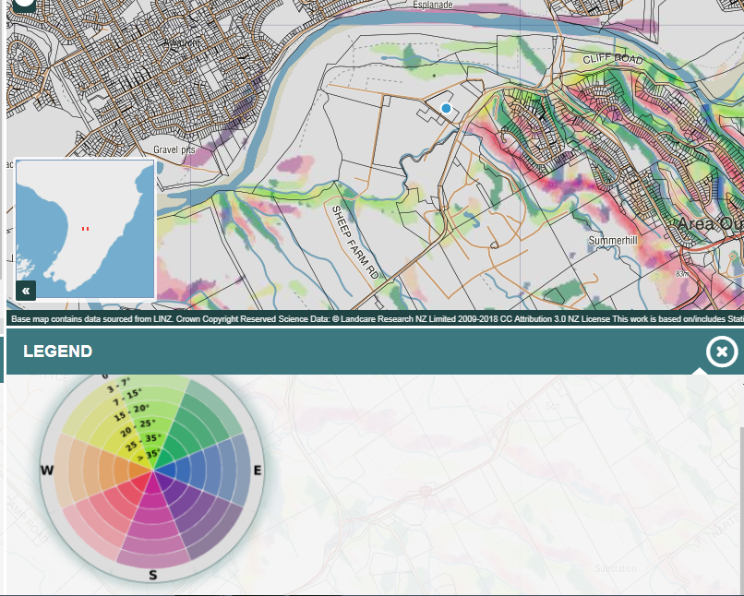
* Land uses – colour coded, areas suitable for arable cropping. Areas that are protected by DOC.   
  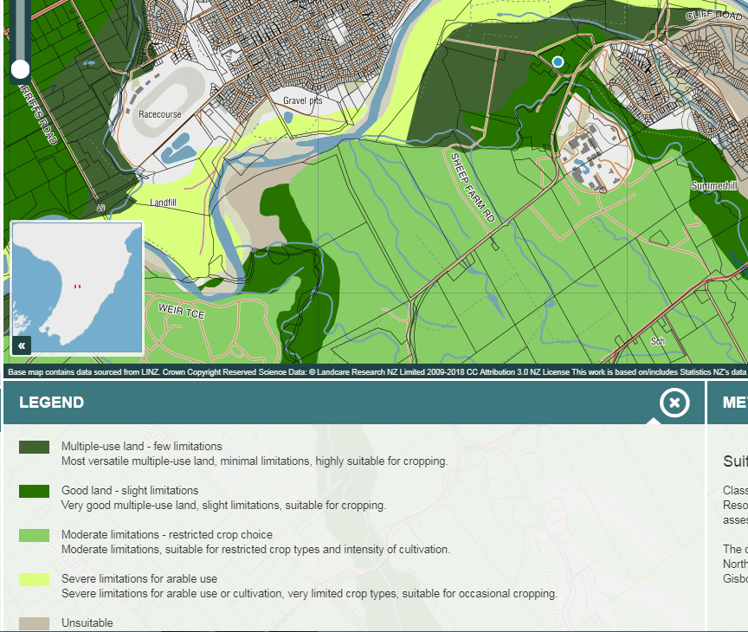
* Add/remove layers with regard to Ecosystem Services : Water Yield, Sediment retained and lost, Greenhouse gas emission.
* We think this could be a good idea to graphically represent data by adding and removing layers on to the map that indicate land use/soils.
* Habitats/threatened environment areas
* Potential Natural Vegetation Pre-human past  
  - Shows different trees (Native conifers, Rimu-matai, Kauri etc.)   
  - Colour coded.
* 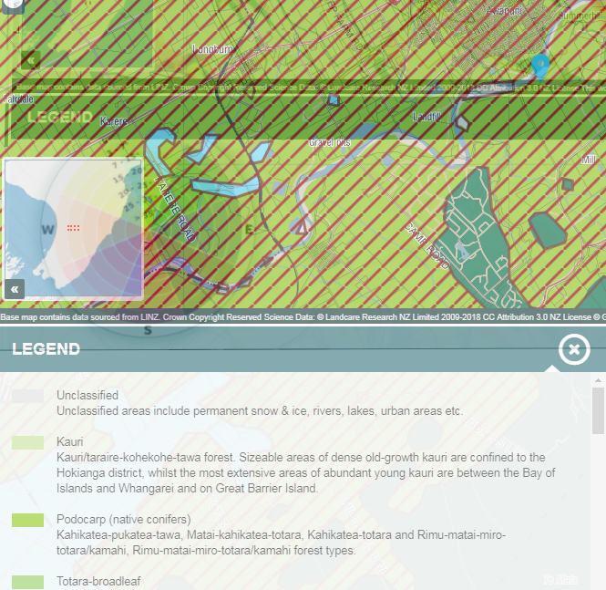

**Viewer-nsdr.landcareresearch.co.nz**

* Website useful for past soil types and analysis (as far back 1977)
* NZ soil classification
* On the map there are various points, once clicked taken to a new tab with information on soil profile morphology, soil classification and soil profile.
* Difficulties with website: theres missing data in some areas.

**Soils.landcareresearch.co.nz**

* A lot of information
* But provides a thorough explanation of soil classification, history of soils in New Zealand
* Soil surveys and data how samples are collected
* National soil data base
* Links to other resources “SoilWebEarth” accessible via google earth